The Plot Pane

The Plot Pane provides a view of the currently loaded dataset as a scatterplot of observations, graphing brightness vs time (or phase). This is referred to as a “light curve”. Here is a light curve for LX Cyg:

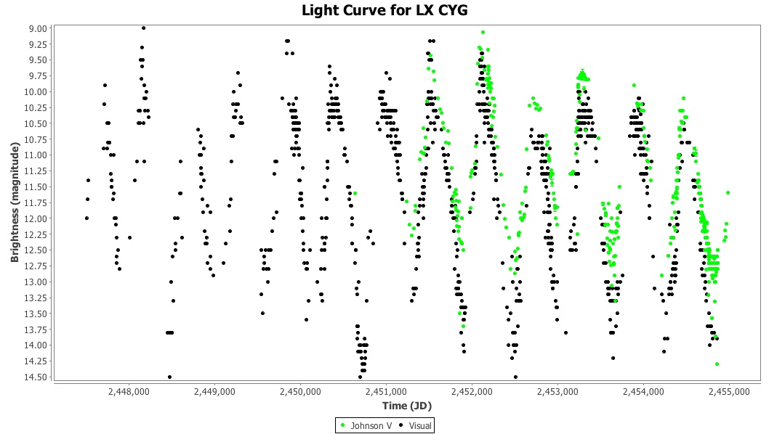

The same dataset in phase plot mode, folded on a period of ~582.188 days, is shown below:
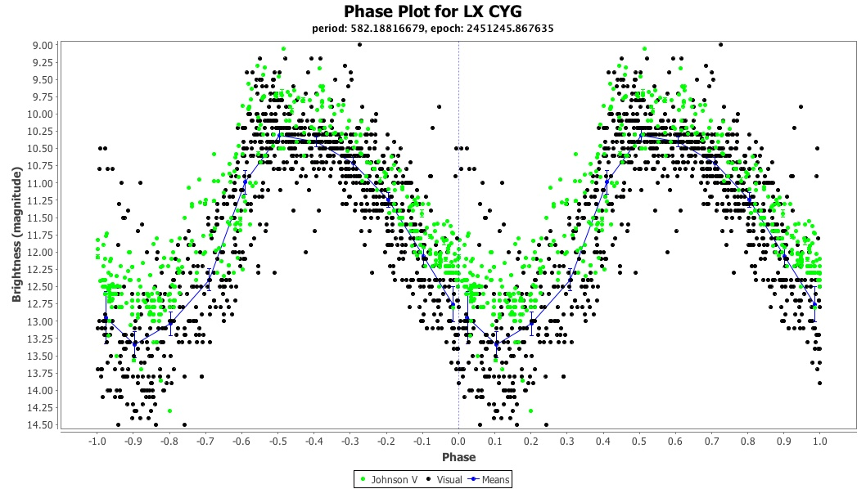

Other than the fact that this shows a phase plot, the other differences from the light curve view are that:

- A mean series has been added. See Plot Control Dialog section.
- Period and epoch are shown as a sub-title.
- The X axis is labelled “Phase” instead of “Time”.

Selecting a data point with the mouse sets the cross-hairs, e.g.

Consider the following W UMa light curve:
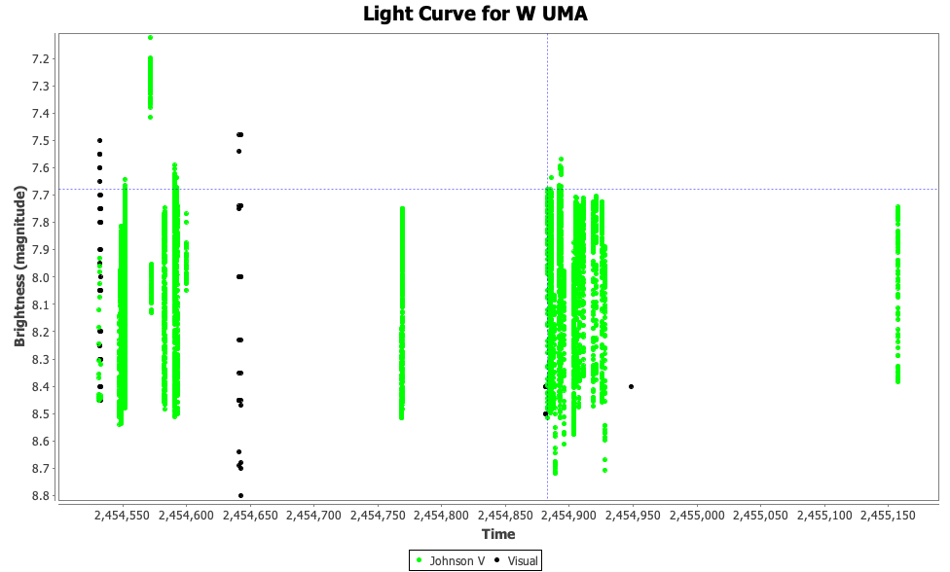
Once selected, a number of operations can be carried out:

- the observation can be excluded via Edit → Exclude Selection;
- the details of the observation can be viewed via the Observation Details Dialog or Observation List (see the corresponding sections for more detail);
- attributes of the selected observation can be made available for observation filtering (see the Filtering Observations section);
- the Plot Pane can be zoomed or panned; these operations are covered next.

On the W UMa plot above, it would be useful to be able to see more detail on a smaller time scale. This is possible in a number of ways:

- Drawing a bounding box with the mouse (click and drag) around an area of the plot. To zoom out again, a click-drag-left mouse gesture is used.

- Selecting a point on the plot then using the zoom buttons in the toolbar or the View menu’s Zoom In and Zoom Out items:
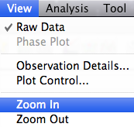
- Use the zoom items of the context menu (e.g. by right-clicking on Windows, ctrl-click on Mac OS X):
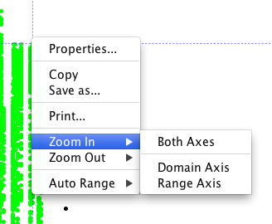

Using the first method above, drawing a bounding box around the section near the cross-hairs to the lower left (JD range: 2454881 to 2454949, magnitude range: 7.5 to 8.75), gives a view like this:
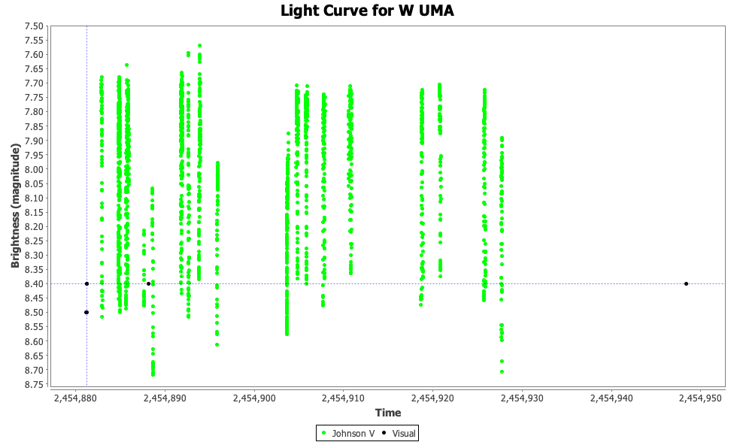

Even at this “magnification” level, one can begin to glimpse that something other than vertical lines exists in this plot. Zooming in further, this time from around JD 2454904 to 2454905 (magnitude 7.7 to 8.4), the following is revealed:

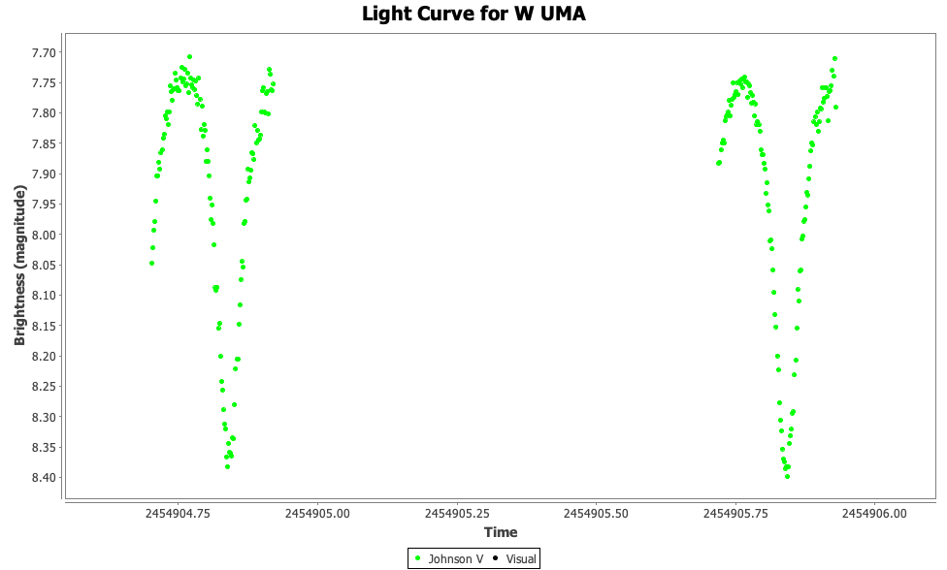

When looking at a magnified view, the pan left, right, up, down View menu items or toolbar buttons can be used to move to regions of the plot not visible.

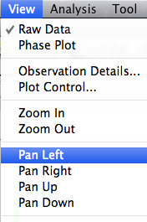

For example, the following is the result of panning the above plot left and down several times:
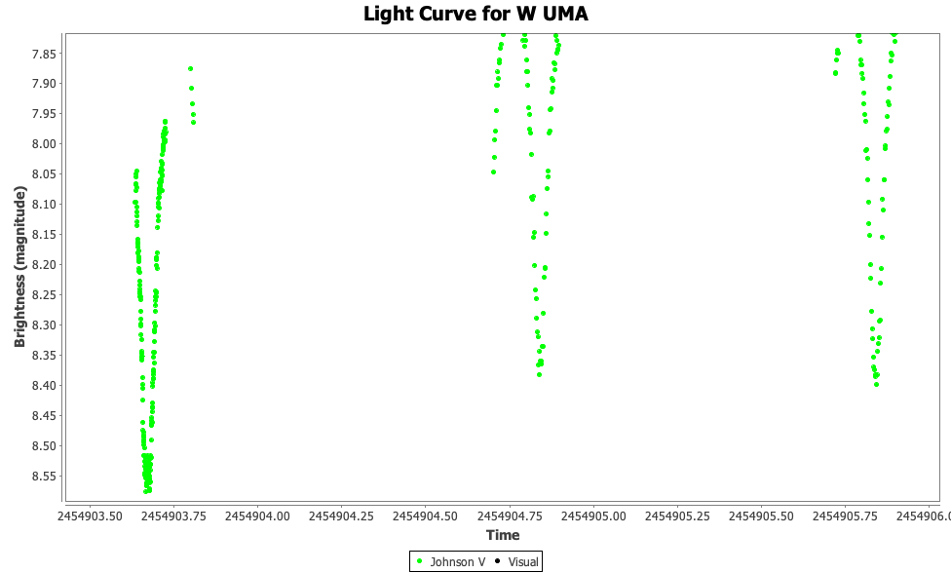

The following shows a phase plot of this dataset at a period (from VSX) of 0.33363749 days:

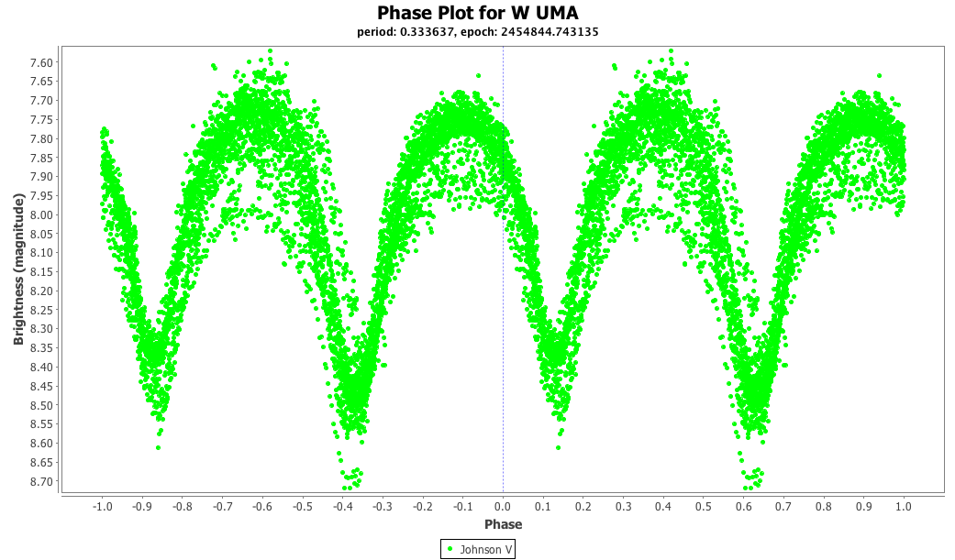
The contents of the Plot Pane can be saved to a file as a PNG image or printed via the File menu’s Save... and Print... items or the corresponding toolbar buttons.

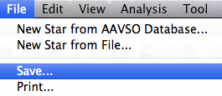

An example of the Save Dialog is shown below. All plot image files are saved in PNG format. If the filename entered does not have a “.png” or “.PNG” suffix, VStar will add this. In the example below, when the Save button is clicked, the current plot will be saved to a file called “omiCetLC.png”.
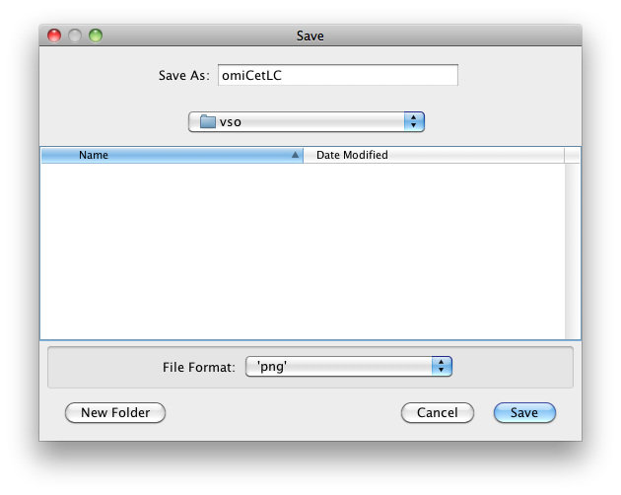
The Print Dialog looks like this on a Mac OS X machine:
